**EXPERIMENT-6**

**Student Name:** Shalini Kumari **UID:**22BET10202

**Branch:** BE -IT **Section/Group:**22BET_IOT-703(A)

**Semester:** 6th **Subject Code:** 22ITP-351

# PROBLEM-1

## AIM:-

Maximum Depth of Binary Tree

**CODE:-**

/**

* Definition for a binary tree node.

* struct TreeNode {

* int val;

* TreeNode *left;

* TreeNode *right;

* TreeNode() : val(0), left(nullptr), right(nullptr) {}

* TreeNode(int x) : val(x), left(nullptr), right(nullptr) {}

* TreeNode(int x, TreeNode *left, TreeNode *right) : val(x), left(left), right(right) {}

* };

*/

class Solution {

public:

int maxDepth(TreeNode* root) {

if(root==nullptr){

return 0;

}

int leftdepth=maxDepth(root->left);

int rightdepth=maxDepth(root->right);

return 1+max(leftdepth,rightdepth);

}

};

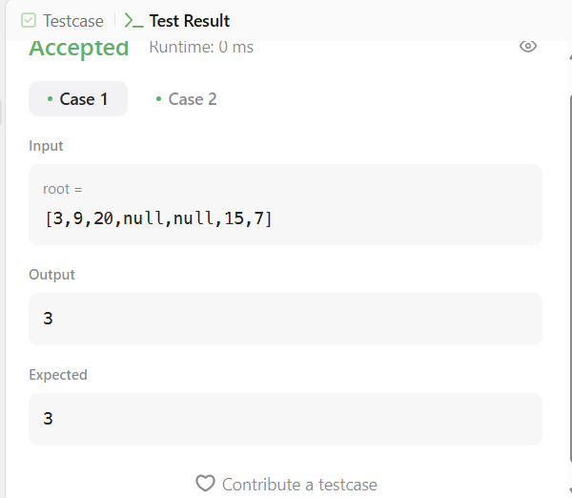

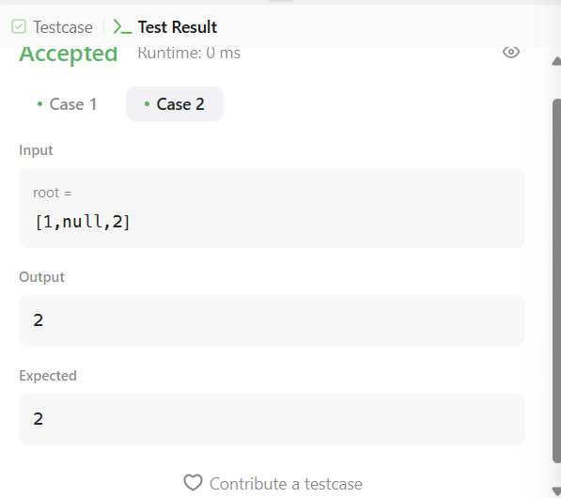

# PROBLEM-2

**AIM:-**

Validate Binary Search Tree

## CODE:-

## class Solution {

## bool isPossible(TreeNode* root, long long l, long long r){

## if(root == nullptr) return true;

## if(root->val < r and root->val > l)

## return isPossible(root->left, l, root->val) and

## isPossible(root->right, root->val, r);

## else return false;

## }

## public:

## bool isValidBST(TreeNode* root) {

## long long int min = -1000000000000, max = 1000000000000;

## return isPossible(root, min, max);

## }

## };

## OUTPUT:-

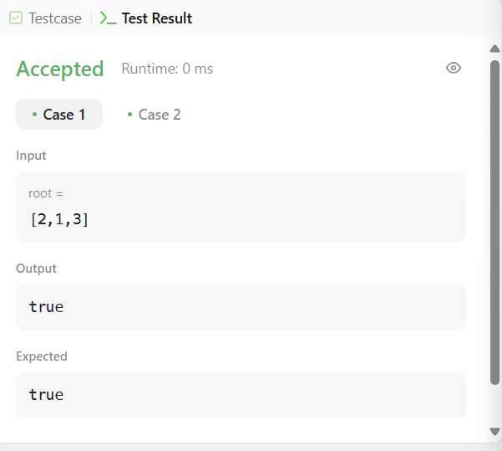

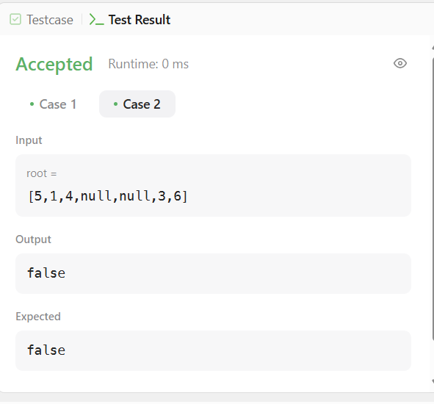

# PROBLEM-3

**AIM:-**

Symmetric Tree

## CODE:-

class Solution { public int numDecodings(String s) { if (s.charAt(0) == '0') { return 0;

}

int n = s.length(); int[] dp = new int[n + 1]; dp[0] = dp[1] = 1;

for (int i = 2; i <= n; i++) { int one = Character.getNumericValue(s.charAt(i - 1)); int two = Integer.parseInt(s.substring(i - 2, i));

if (1 <= one && one <= 9) {

dp[i] += dp[i - 1];

}

if (10 <= two && two <= 26) {

dp[i] += dp[i - 2];

}

}

return dp[n];

}

}

## OUTPUT:-

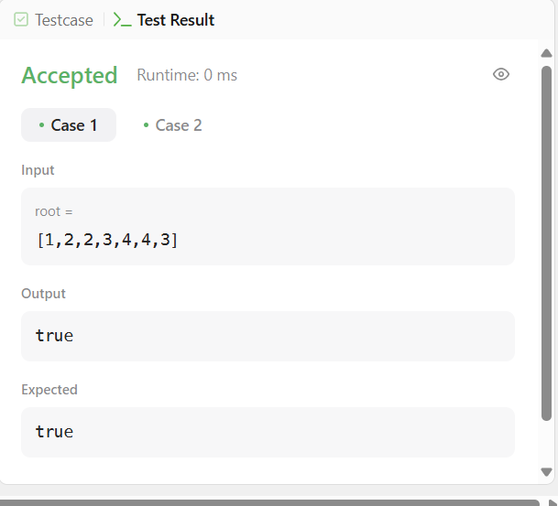

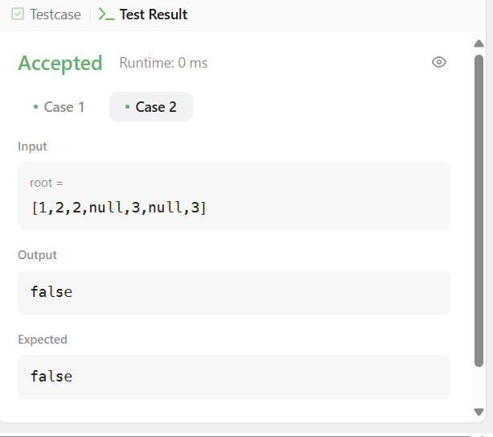

# PROBLEM-4

**AIM:-**

Binary Tree Level Order Traversal

## CODE:-

class Solution { public int coinChange(int[] coins, int amount) { int[] minCoins = new int[amount + 1]; Arrays.fill(minCoins, amount + 1); minCoins[0] = 0;

for (int i = 1; i <= amount; i++) { for (int j = 0; j < coins.length; j++) { if (i - coins[j] >= 0) { minCoins[i] = Math.min(minCoins[i], 1 + minCoins[i - coins[j]]);

}

}

}

return minCoins[amount] != amount + 1 ? minCoins[amount] : -1;

}

## } OUTPUT:-

## 

## 

# PROBLEM-5

**AIM:-**

Convert Sorted Array to Binary Search

## CODE:-

class Solution {

public:

    vector<vector<int>> levelOrder(TreeNode* root) {

        vector<vector<int>>ans;

        if(root==NULL)return ans;

        queue<TreeNode*>q;

        q.push(root);

        while(!q.empty()){

            int s=q.size();

            vector<int>v;

            for(int i=0;i<s;i++){

                TreeNode *node=q.front();

                q.pop();

                if(node->left!=NULL)q.push(node->left);

                if(node->right!=NULL)q.push(node->right);

                v.push_back(node->val);

            }

            ans.push_back(v);

        }

        return ans;

    }

};

**OUTPUT:**

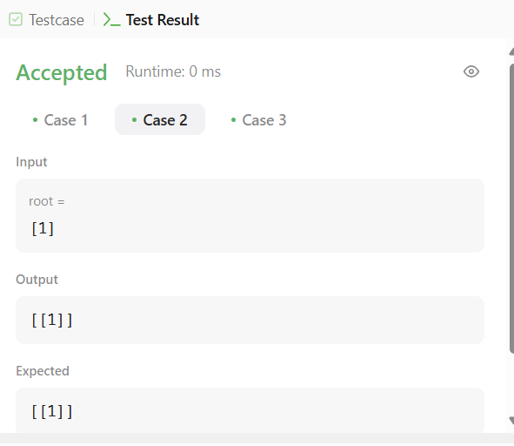

# PROBLEM-6

**AIM:-**

Binary Tree Inorder Traversal

## CODE:-

## /**

## * Definition for a binary tree node.

## * struct TreeNode {

## * int val;

## * TreeNode *left;

## * TreeNode *right;

## * TreeNode() : val(0), left(nullptr), right(nullptr) {}

## * TreeNode(int x) : val(x), left(nullptr), right(nullptr) {}

## * TreeNode(int x, TreeNode *left, TreeNode *right) : val(x), left(left), right(right) {}

## * };

## */

## class Solution {

## public:

## void inorder(TreeNode* root,vector<int>&nums){

## if(root==NULL){

## return ;

## }

## inorder(root->left,nums);

## nums.push_back(root->val);

## inorder(root->right,nums);

## }

## vector<int> inorderTraversal(TreeNode* root) {

## vector<int>nums;

## inorder(root,nums);

## return nums;

## }

## };

## OUTPUT:-

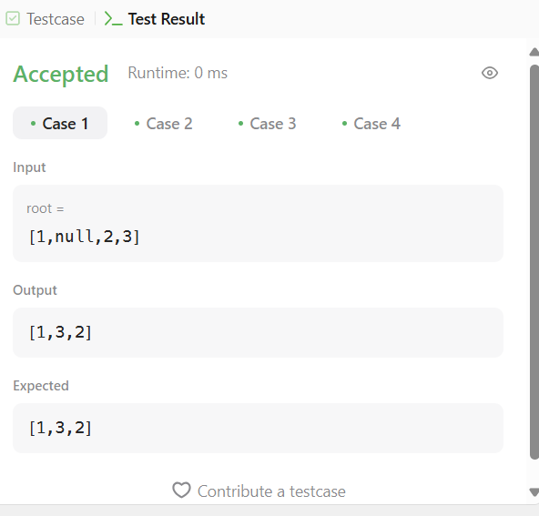

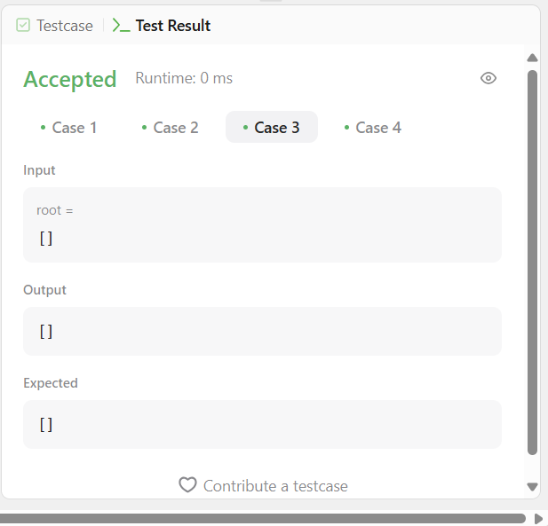

# PROBLEM-7

## AIM:-

Binary Zigzag Level Order Traversal

**CODE:-** import java.util.*;

class Solution { public List<String> wordBreak(String s, List<String> wordDict) {

Set<String> wordSet = new HashSet<>(wordDict);

Map<Integer, List<String>> memo = new HashMap<>();

return backtrack(s, 0, wordSet, memo);

}

private List<String> backtrack(String s, int start, Set<String> wordSet, Map<Integer, List<String>> memo) { if (memo.containsKey(start)) { return memo.get(start);

}

List<String> result = new ArrayList<>();

if (start == s.length()) { result.add(""); return result;

}

for (int end = start + 1; end <= s.length(); end++) {

String word = s.substring(start, end);

if (wordSet.contains(word)) {

List<String> sublist = backtrack(s, end, wordSet, memo); for (String sub : sublist) { if (sub.isEmpty()) { result.add(word);

} else {

result.add(word + " " + sub);

}

}

}

}

memo.put(start, result); return result;

}

}

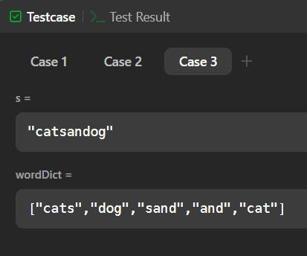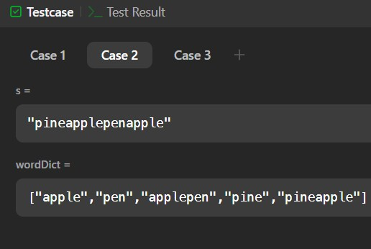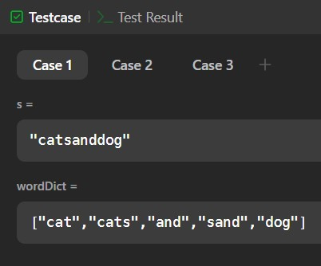

**Problem 8:**

Construsct a binary tree:

**CODE:**

**/\*\***

**\* Definition for a binary tree node.**

**\* struct TreeNode {**

**\* int val;**

**\* TreeNode *left;**

**\* TreeNode *right;**

**\* TreeNode() : val(0), left(nullptr), right(nullptr) {}**

**\* TreeNode(int x) : val(x), left(nullptr), right(nullptr) {}**

**\* TreeNode(int x, TreeNode *left, TreeNode *right) : val(x), left(left), right(right) {}**

**\* };**

**\*/**

**class Solution {**

**public:**

**TreeNode* solve(vector<int>&inorder, int InStart, int InEnd, vector<int>& postorder, int PostStart, int PostEnd, map<int, int>&mpp){**

**if(InStart>InEnd || PostStart> PostEnd) return NULL;**

**TreeNode* node = new TreeNode(postorder[PostEnd]);**

**int node_position = mpp[node->val];**

**int leftLen = node_position - InStart;**

**node->left = solve(inorder,InStart, node_position-1, postorder, PostStart, PostStart + leftLen-1, mpp);**

**node->right = solve(inorder,node_position+1, InEnd, postorder, PostStart+leftLen, PostEnd-1, mpp);**

**return node;**

**}**

**TreeNode* buildTree(vector<int>& inorder, vector<int>& postorder) {**

**map<int, int>mpp;**

**for(int i=0;i<inorder.size();++i){**

**mpp[inorder[i]] = i;**

**}**

**TreeNode* root = solve(inorder, 0, inorder.size()-1, postorder, 0, postorder.size()-1, mpp);**

**return root;**

**}**

**};**

**OUTPUT:**

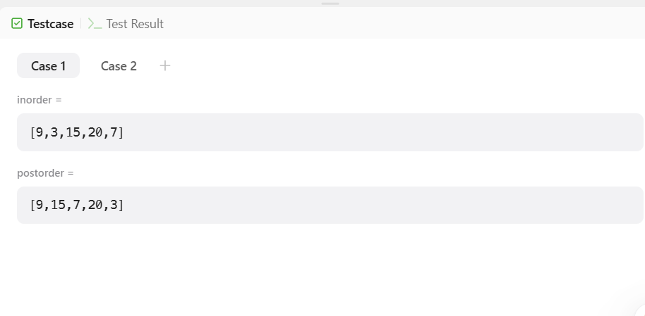

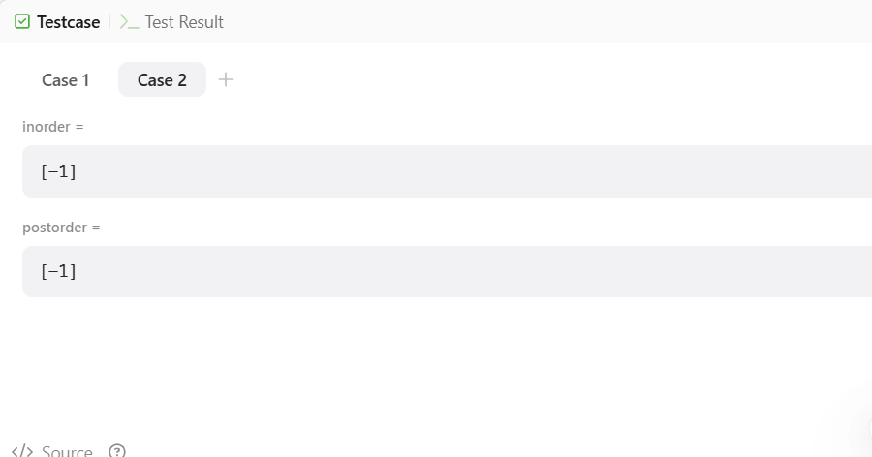

**PROBLEM -9**

Print KTH element

**CODE**

# Definition for a binary tree node.

# class TreeNode:

# def __init__(self, val=0, left=None, right=None):

# self.val = val

# self.left = left

# self.right = right

class Solution:

def kthSmallest(self, root: Optional[TreeNode], k: int) -> int:

arr=[]

def inorder(root):

if root:

inorder(root.left)

arr.append(root.val)

inorder(root.right)

inorder(root)

return arr[k-1]

**OUTPUT:**

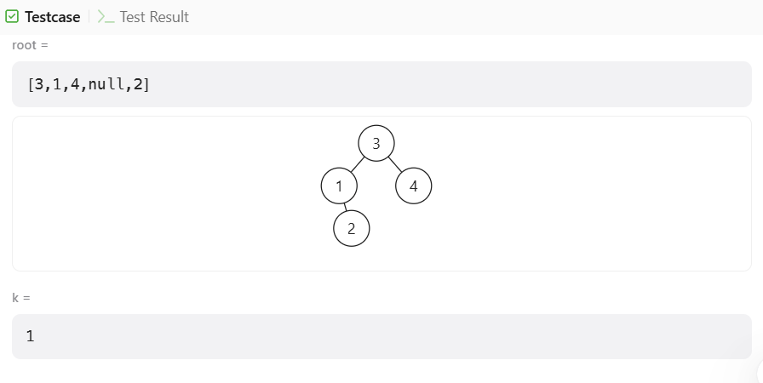

**PROBLEM -10**

Populating next right pointers

**Code:**

class Solution {

public:

Node* connect(Node* root) {

if(!root) return nullptr;

queue<Node*> q;

q.push(root);

while(size(q)) {

Node* rightNode = nullptr; // set rightNode to null initially

for(int i = size(q); i; i--) { // traversing each level

auto cur = q.front(); q.pop(); // pop a node from current level and,

cur -> next = rightNode; // set its next pointer to rightNode

rightNode = cur; // update rightNode as cur for next iteration

if(cur -> right) // if a child exists

q.push(cur -> right), // IMP: push right first to do right-to-left BFS

q.push(cur -> left); // then push left

}

}

return root;

}

};

**OUTPUT:**

